 

**FABRICATION OF MINIATURE WINDMILL**

### A PROJECT REPORT

***Submitted by***

**S. KAVISH (927622BME039)**

**T. KEERTHIGA (927622BME040)**

**D. LOGESHWARAN (927622BME308)**

***in partial fulfilment for the award of the degree***

***of***

**BACHELOR OF ENGINEERING**

**IN**

**MECHANICAL ENGINEERING**

**M.KUMARASAMY COLLEGE OF ENGINEERING, KARUR ANNA UNIVERSITY: CHENNAI 600 025**

 

FABRICATION OF MINIATURE WINDMILL

### A PROJECT REPORT

***Submitted by***

**S. KAVISH (927622BME039)**

**T. KEERTHIGA (927622BME040)**

**D. LOGESHWARAN (927622BME308)**

***in partial fulfilment for the award of the degree of***

**BACHELOR OF ENGINEERING**

***IN***

MECHANICAL ENGINEERING

**M.KUMARASAMY COLLEGE OF ENGINEERING, KARUR**

**ANNA UNIVERSITY:CHENNAI 600 025**

# M.KUMARASAMY COLLEGE OF ENGINEERING, KARUR

BONAFIDE CERTIFICATE

Certified that this project report **“FABRICATION OF MINIATURE WINDMILL”** is the bonafide work of **“S. KAVISH (927622BME039), T. KEERTHIGA (927622BME040),**

**D. LOGESHWARAN (927622BME308)”** who carried out the project work during the academic year 2023 – 2024 under my supervision. Certified further, that to the best of my knowledge the work reported here is not a part of any other project report or dissertation on the basis of which a degree or award was conferred on an earlier occasion on this or any other candidate.

**SIGNATURE SIGNATURE**

Dr. M. LOGANATHAN M.E., PH.D., Mr. S. SATHEESH KUMAR M.E.,

**HEAD OF THE DEPARTMENT ASSISTANT PROFESSOR**

Department of Mechanical Engineering, Department of Mechanical Engineering,

M.Kumarasamy College of Engineering, M.Kumarasamy College of Engineering,

Thalavapalayam, Karur-639113. Thalavapalayam, Karur-639113.

This project report has been submitted for the end semester project viva voce Examination held on

INTERNAL EXAMINER EXTERNAL EXAMINER

# DECLARATION

We affirm that the Project titled **“FABRICATION OF MINIATURE WINDMILL”** being submitted in partial fulfilment of for the award of Bachelor of Engineering in Mechanical Engineering, is the original work carried out by us. It has not formed the part of any other project or dissertation on the basis of which a degree or award was conferred on an earlier occasion on this or any other candidate.

Student name Signature

1. S. KAVISH -----------------------------
2. T. KEERTHIGA ----------------------------
3. D. LOGESHWARAN ---------------------------

Name and signature of the supervisor with date

### ACKNOWLEDGEMENT

Our sincere thanks to Founder Thiru. M. Kumarasamy and Dr. K. Ramakrishnan, B.E, Chairman of M. Kumarasamy College of Engineering for providing extra ordinary infrastructure, which helped us to complete the project in time.

It is a great privilege for us to express our gratitude to our esteemed Principal Dr. B.S. Murugan M.E., Ph.D. for providing us right ambiance for carrying out the project work.

We would like to thank Dr. M.Loganathan M.E, Ph.D, Head, Department of Mechanical Engineering, for their unwavering moral support throughout the evolution of the project.

We offer our whole hearted thanks to our internal guide Mr. S. Satheesh Kumar M.E., Assistant Professor, Department of Mechanical Engineering, for his constant encouragement, kind co-operation, valuable suggestions and support rendered in making our project a success.

We offer our whole hearted thanks to our project coordinator Dr. H. Vinoth Kumar M.E., Department of Mechanical Engineering, for his constant encouragement, kind co-operation, valuable suggestions and support rendered in making our project a success.

We glad to thank all the Teaching and Non-Teaching Faculty Members of Department of Mechanical Engineering for extending a warm helping hand and valuable suggestions throughout the project. Words are boundless to thank Our Parents and Friends for their constant encouragement to complete this project successfully.

### INSTITUTION VISION & MISSION

#### Vision

 To emerge as a leader among the top institutions in the field of technical education.

#### Mission

 Produce smart technocrats with empirical knowledge who can surmount the global challenges.

 Create a diverse, fully-engaged, learner-centric campus environment to provide quality education to the students.

 Maintain mutually beneficial partnerships with our alumni, industry and professional associations.

### DEPARTMENT VISION, MISSION, PEO, PO & PSO

#### Vision

 To create globally recognized competent Mechanical engineers to work in multicultural environment.

#### Mission

 To impart quality education in the field of mechanical engineering and to enhance their skills, to pursue careers or enter into higher education in their area of interest.

 To establish a learner-centric atmosphere along with state-of-the-art research facility.

 To make collaboration with industries, distinguished research institution and to become a centre of excellence

### PROGRAM EDUCATIONAL OBJECTIVES (PEOS)

The graduates of Mechanical Engineering will be able to

 PEO1: Graduates of the program will accommodate insightful information of engineering principles necessary for the applications of engineering.

 PEO2: Graduates of the program will acquire knowledge of recent trends in technology and solve problem in industry.

 PEO3: Graduates of the program will have practical experience and interpersonal skills to work both in local and international environments.

 PEO4: Graduates of the program will possess creative professionalism, understand their ethical responsibility and committed towards society.

### PROGRAM OUTCOMES

The following are the Program Outcomes of Engineering Graduates: Engineering Graduates will be able to:

1. **Engineering knowledge:** Apply the knowledge of mathematics, science, engineering fundamentals, and an engineering specialization to the solution of complex engineering problems.
2. **Problem analysis:** Identify, formulate, review research literature, and analyse complex engineering problems reaching substantiated conclusions using first principles of mathematics, natural sciences, and engineering sciences.
3. **Design/development of solutions:** Design solutions for complex engineering problems and design system components or processes that meet the specified needs with appropriate consideration for the public health and safety, and the cultural, societal, and environmental considerations.
4. **Conduct investigations of complex problems:** Use research-based knowledge and research methods including design of experiments, analysis and interpretation of data, and synthesis of the information to provide valid conclusions.
5. **Modern tool usage:** Create, select, and apply appropriate techniques, resources, and modern engineering and IT tools including prediction and modelling to complex engineering activities with an understanding of the limitations.
6. **The engineer and society:** Apply reasoning informed by the contextual knowledge to assess societal, health, safety, legal and cultural issues and the consequent responsibilities relevant to the professional engineering practice.
7. **Environment and sustainability:** Understand the impact of the professional engineering solutions in societal and environmental contexts, and demonstrate the knowledge of, and need for sustainable development.
8. **Ethics:** Apply ethical principles and commit to professional ethics and responsibilities and norms of the engineering practice.
9. **Individual and team work:** Function effectively as an individual, and as a member or leader in diverse teams, and in multidisciplinary settings.
10. **Communication:** Communicate effectively on complex engineering activities with the engineering community and with society at large, such as, being able to comprehend and write effective reports and design documentation, make effective presentations, and give and receive clear instructions.
11. **Project management and finance:** Demonstrate knowledge and understanding of the engineering and management principles and apply these to one’s own work, as a member and leader in a team, to manage projects and in multidisciplinary environments.
12. **Life-long learning:** Recognize the need for, and have the preparation and ability to engage in independent and life-long learning in the broadest technological change.

**PROGRAM SPECIFIC OUTCOMES (PSOs)**

**The following are the Program Specific Outcomes of Engineering Graduates:**

The students will demonstrate the abilities

* 1. **Real world application:** To comprehend, analyse, design and develop innovative products and provide solutions for the real-life problems.
  2. **Multi-disciplinary areas:** To work collaboratively on multi-disciplinary areas and make quality projects.

**Research oriented innovative ideas and methods:** To adopt modern tools, mathematical, scientific and engineering fundamentals required to solve industrial and societal problems

|  |  |  |
| --- | --- | --- |
| **Course Outcomes** | At the end of this course, learners will be able to: | **Knowledge Level** |
| CO-1 | Identify the issues and challenges related to industry, society and environment. | Apply |
| CO-2 | Describe the identified problem and formulate the  possible solutions | Apply |
| CO-3 | Design / Fabricate new experimental set up/devices to provide solutions for the identified problems | Analyse |
| CO-4 | Prepare a detailed report describing the project outcome | Apply |
| CO-5 | Communicate outcome of the project and defend by making an effective oral presentation. | Apply |

**MAPPING OF PO & PSO WITH THE PROJECT OUTCOME**

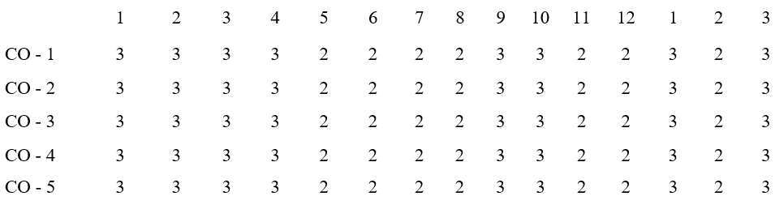

**Program**

**Course**

**Program Outcomes**

**Specific**

**Outcomes**

**Outcomes**

## TABLE OF CONTENT

|  |  |  |
| --- | --- | --- |
| CHAPTER | TITLE | PAGE NO |
| 1 | ABSTRACT | 10 |
| 2 | INTRODUCTION | 11 |
| 3 | SCOPE OF THE PROJECT | 12 |
| 4 | LITERATURE REVIEW | 13 |
| 5 | COMPONENTS | 14 |
| 6 | WORKING | 16 |
| 7 | BLOCK DIAGRAM | 23 |
| 8 | WORKING MODEL | 24 |
| 9 | ADVANTAGES & DISADVANTAGES | 25 |
| 10 | COST ESTIMATION | 26 |
| 11 | CONCLUSION | 29 |
| 12 | REFERENCE | 30 |

CHAPTER 1

**ABSTRACT**

This project focuses on the development of a miniature windmill system for sustainable energy generation. The object is to create a compact and efficient wind turbine design suitable for various applications, including powering small electronics devices and sensors. The project encompasses the design, fabrication, and testing on the miniature windmill, incorporating innovative aerodynamic principles and materials to maximize energy conversion. The research aims to contribute the advancement of micro wind energy systems, offering a renewable and eco-friendly power source for low power applications. Results from the project indicate the potential for harnessing wind energy at smaller scale, paving the way for greener and more versatile energy solutions in the future.

CHAPTER 2

### INTRODUCTION

In many parts of the world, you can tap the power of the wind to generate non polluting renewable electricity. Wind plant designs have improved so much and the cost of the oil, coal, natural gas and nuclear power are so high that many power companies are building large scale wind plants.

The more we relay on renewable energy, the less dependent we are on utility giants and non renewable, polluting fossil fuels. With world oil and gas supplies dwindling experts estimate electricity prices will increase significantly in the coming years. A wind plant, especially in concert with a solar-electric photovoltaic (PV) system, is a becoming a cost -effective way to meet the energy needs.

To encourage the shift to wind and solar power, various government programs offer personal tax credits, property tax exemptions, low -interest loans and rebate programs.

CHAPTER 3

### SCOPE OF PROJECT

The miniaturized windmill project operates by harnessing wind energy through a compact turbine system. When exposed to wind, the lightweight blades rotate around a central hub. This rotational motion is transferred to a generator, converting mechanical energy into electrical power. The generator output is then stored in a battery or directly utilized to power small electronic devices. The design prioritizes efficiency in capturing energy from low to moderate wind speeds, making it suitable for portable and sustainable energy solutions in various applications.

### LITERATURE REVIEW

CHAPTER 4

This review delves into the existing literature on miniature windmill design, fabrication, performance, and potential applications.

#### Design and Optimization: Blade Design:

Studies like "Design and Fabrication of Mini Windmill Power Generator" by IJRCS and "Investigation on the Performance of Rotor for Micro Wind Turbine Application" by Energy Procedia analyse various blade designs. Popular choices include rotors (S-rotors), H- rotors, and Darrieus rotors, each with its own advantages and drawbacks regarding efficiency, starting torque, and omnidirectional capabilities.

#### Material Selection:

Research articles like "Design and Development of Miniature Wind Turbine" by IRJET explore the use of diverse materials like PVC, wood, fiberglass, and composite materials. The choice depends on factors like cost, ease of fabrication, weight, and durability.

#### Optimization Techniques:

Studies like "Computational Investigation of the Performance of Small Wind Turbine Blades" by Renewable Energy use computational fluid dynamics (CFD) simulations to optimize blade shape, angles, and number for maximized power output under specific wind conditions.

#### Fabrication Techniques: Simple Methods:

Resources like Magezine and Instructables offer DIY tutorials for building miniature windmills using readily available materials like cardboard, wood, and plastic bottles. These methods are ideal for beginners and educational purposes.

#### Advanced Techniques:

Research papers like "Design and Fabrication of Wind Mill for Small Application" discuss 3D printing, laser cutting, and metalworking techniques for creating more complex and efficient designs. These methods demand higher technical skills and access to specialized equipment

CHAPTER 5

### COMPONENT SPECIFICATION

* Windmill
* At mega microcontroller
* LCD display
* Crystal Oscillator
* Resistors
* Capacitors
* Transistors
* Cables and Connectors
* Diodes
* PCB and Breadboards
* LCD
* Transformer and Adaptors
* Push button
* Switch
* IC socket

## CHAPTER 6

### WORKING :

LCDs contribute to the slim and lightweight design of devices, making them more portable and aesthetically appealing compared to older display technologies.

### LCD DISPLAY

**Visual Output:**

LCDs provide a visual display for devices such as monitors, TVs, smartphones, and digital cameras, presenting information in a clear and readable format.

#### Instruction Set:

Atmega microcontrollers use a reduced instruction set (RISC) architecture, which simplifies instruction execution and enhances performance.

#### Power Management:

Atmega microcontrollers provide power-saving features such as sleep modes and low- power consumption modes, making them suitable for battery-powered applications.

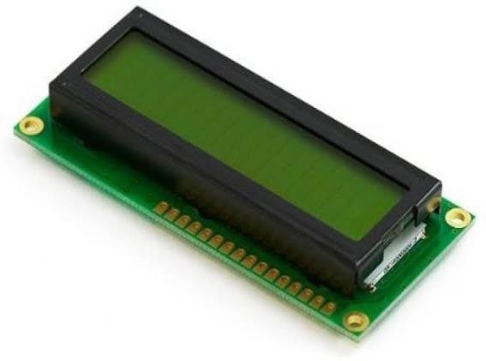

Fig.no.1

### CRYSTAL OSCILLATOR:

#### Crystal Element:

The heart of a crystal oscillator is a small piece of quartz crystal. Quartz is commonly used due to its stability and piezoelectric properties.

#### Feedback Circuit:

The crystal is connected to an electronic circuit that provides feedback. The feedback circuit amplifies and sustains the oscillations of the crystal at its resonant frequency

#### Inverter and Amplifier:

The feedback circuit typically includes an inverter and an amplifier. The inverter inverts the signal phase, and the amplified signal is fed back to the crystal. This positive feedback helps maintain the oscillations.

#### Output Signal:

The crystal oscillator produces a stable and precise sinusoidal waveform at its resonant frequency. This output signal is then used as a reference clock or frequency source in electronic systems.

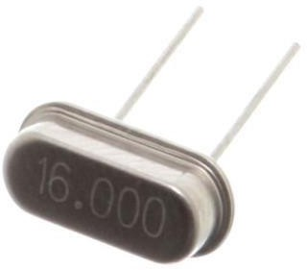

Fig.no.2

### RESISTOR

#### Ohm's Law:

According to Ohm's Law, the relationship between voltage (V), current (I), and resistance (R) is expressed as V = I * R. In other words, the voltage across a resistor is directly proportional to the current flowing through it, with resistance being the constant of proportionality.

#### Voltage Drop:

As current flows through the resistor, there is a voltage drop across it, which is equal to the product of the current and the resistance (V = I * R). This voltage drop is a fundamental aspect of how resistors function in electrical circuits

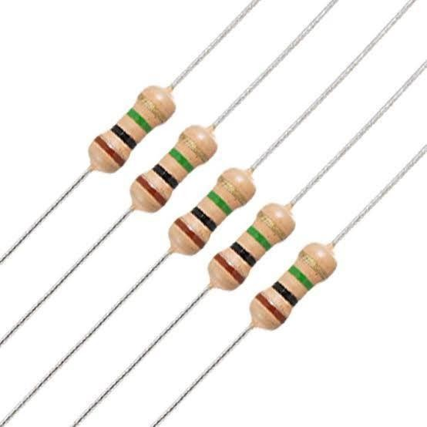

Fig.no.3

### CAPACITOR

#### Stored Charge:

As the capacitor charges, it stores electrical energy in the form of accumulated charge on its plates. The ability to store charge is quantified by the capacitance (C) of the capacitor, measured in farads (F). The capacitance depends on the surface area of the plates, the distance between them, and the dielectric constant of the material between the plates.

#### Energy Storage:

The energy stored in a capacitor (E) is given by the formula (E = ½. C V^2), where C is the capacitance and V is the voltage across the capacitor. Capacitors can store energy and release it quickly when needed.

#### Discharging:

When the voltage across the capacitor is reduced or the circuit is connected to a lower potential, the stored charge is released.

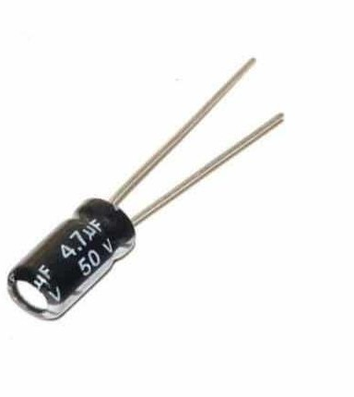

Fig.no.4

### TRANSISTOR

#### Amplification:

Transistors can amplify electrical signals. By controlling the current flowing through them, transistors can significantly increase the strength of weak input signals, making them larger and more powerful at the output.

#### Switching:

Transistors can function as electronic switches. By controlling the flow of current between two terminals (collector and emitter), transistors can turn electronic devices on or off. This switching capability is fundamental to digital electronics and binary systems.

#### Signal Modulation:

In communication systems, transistors are used to modulate signals. By varying the amplitude or frequency of a carrier signal, information can be encoded onto the signal for transmission and later demodulated at the receiving end.

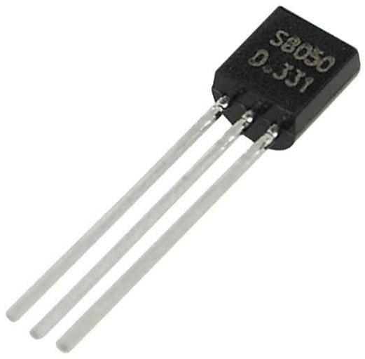

Fig.no.5

### CABLES

#### Conductors:

Cables consist of conductors, typically made of copper or aluminium, which conduct electrical current. The conductors are often insulated to prevent short circuits and ensure proper signal transmission.

#### Insulation:

Insulation materials surround the conductors, preventing electrical contact between them and protecting against external environmental factors. Insulation also helps maintain signal integrity by reducing interference.

#### Cable Types:

Different cables serve specific purposes, such as power cables for delivering electrical power, data cables for transmitting digital signals, and audio/video cables for transferring audio and video signals.

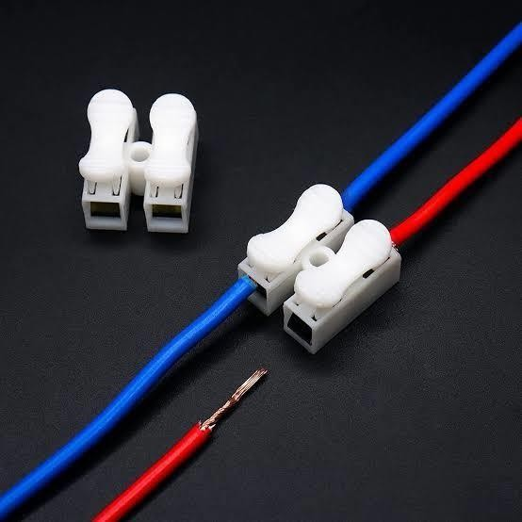

Fig.no.6

### CONNECTORS

#### Physical Connection:

Connectors provide a physical interface between devices and cables. They allow for the secure and stable connection and disconnection of cables from devices.

#### Diodes:

Diodes are semiconductor devices with a crucial role in electronic circuits, primarily functioning as rectifiers. The working principle of diodes is based on their ability to control the direction of electric current flow.

#### Semiconductor Material:

Diodes are typically made of semiconductor materials, often silicon or germanium. These materials have unique electronic properties that enable diodes to exhibit the desired behavior.

### P-N JUNCTION

The basic structure of a diode consists of a P-N junction, where P-type (positively doped) and

N-type (negatively doped) semiconductor materials are joined together. This junction is crucial to the diode's operation.

#### Forward Bias:

When a positive voltage (forward bias) is applied to the P-type material and a negative voltage to the N-type material, it reduces the potential barrier at the junction. Electrons from the N-type material move across the junction, and holes from the P-type material move in the opposite direction, creating a flow of electric current.

#### Reverse Bias:

When a negative voltage (reverse bias) is applied to the P-type material and a positive voltage to the N-type material.

#### PCBs (Printed Circuit Boards) Circuit Interconnection:

PCBs provide a platform for interconnecting electronic components. Copper traces on the board form conductive paths that connect various components and create a complete circuit.

#### Component Mounting:

PCBs allow for the secure mounting of electronic components such as resistors, capacitors, integrated circuits, and more. Components are soldered onto the designated locations on the board.

#### Compact Design:

PCBs enable the creation of compact and space-efficient electronic circuits.

### INTEGRATED CIRCUIT (IC)

#### Replacement:

They allow for easy insertion and removal of ICs, facilitating quick replacement in case of failure or during testing without soldering.

#### Protection:

IC sockets protect the IC from damage during insertion and removal, reducing the risk of bent or damaged pins.

#### Testing and Debugging:

They are useful for testing and debugging purposes, enabling easy swapping of ICs for troubleshooting without the need for desoldering.

#### Flexibility:

Sockets provide flexibility in design by allowing the use of different ICs with the same footprint, which is beneficial for prototypes or when final IC choice is uncertain.

## CHAPTER 7

### BLOCK DIAGRAM:

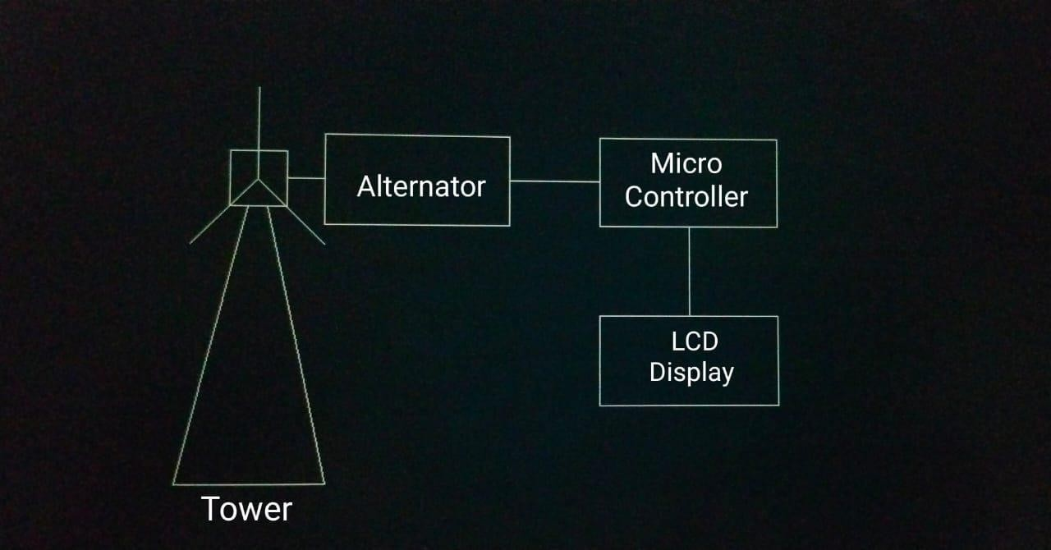

Fig.no.7

## CHAPTER 8

**WORKING MODEL:**

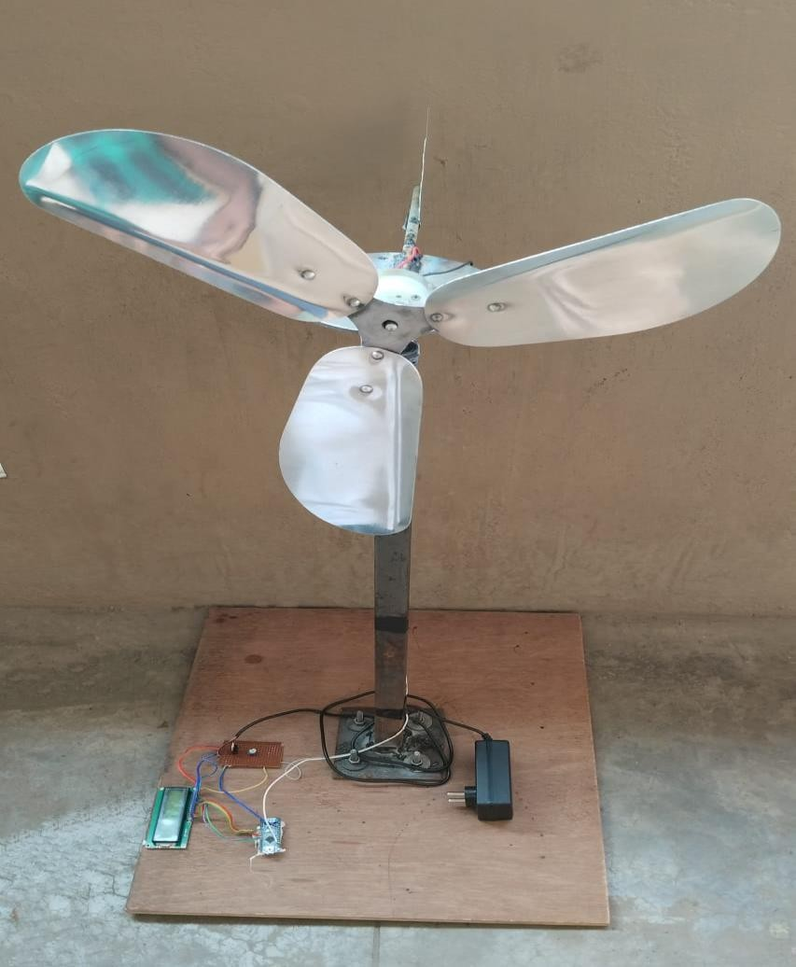

Fig.no.8

## CHAPTER 9

#### Advantages:

* Less cost
* Environment friendly
* Higher efficiency
* Require less space
* Low wind power is enough.

#### Disadvantages:

* Requires regular maintenance.
* Makes little vibration.

#### Application:

* Used in rural areas, mall, colleges, apartments etc.,
* Used as a prototype in symposiums and presentations.

## CHAPTER 10

**COST ESTIMATION**

|  |  |  |
| --- | --- | --- |
| S.NO | COMPONENTS | PRICE |
| 1 | LCD DISPLAY | 450 |
| 2 | BLADES | 210 |
| 3 | TOWER | 250 |
| 4 | CARD BOARD | 500 |
| 5 | ALTERNATOR | 800 |
| 6 | CONNECTING WIRES | 200 |
| 7 | OTHERS | 100 |
| 8 | OTHER EXPENSES | 250 |
|  | TOTAL | 2760 |

**PHOTOGRAPH**

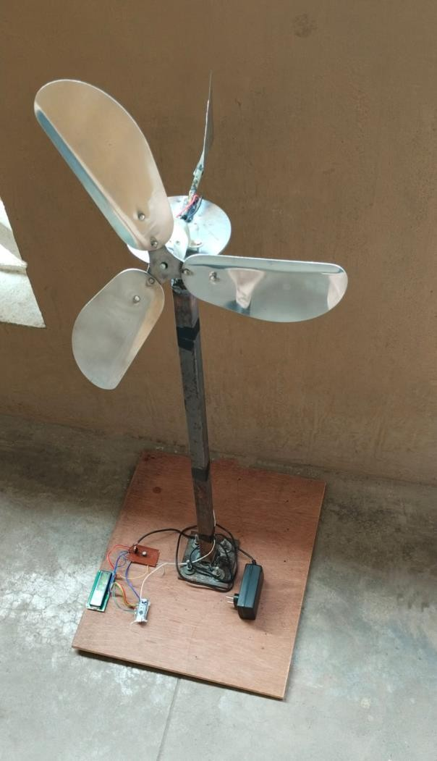

Fig.no.9



Fig.no.10

## CHAPTER 11

#### Conclusion:

The fabrication of the miniature windmill project demonstrates the practical application of renewable energy principles and small-scale engineering. Throughout the project, we successfully designed, constructed and tested a miniature windmill capable of generating electrical power. This project provides valuable hands-on experience in various engineering disciplines including mechanical design, electrical systems, and materials science.

Utilizing CAD software, we were able to create an efficient blade design optimized for maximum energy capture from wind. Construction and Materials by selecting appropriate materials, we ensure durability and efficiency while keeping costs low.

The windmill was equipped with a generator and a simple circuit to store and utilize the generated power, demonstrating its potential for real-world applications. Analysis performance testing under different wind conditions allowed us to evaluate the windmill's efficiency and identify areas for improvement.

Overall, this project underscores the importance and feasibility of wind energy, even at a small scale. It also highlights the potential for further development and scaling up, contributing to sustainable energy solutions. The project has not only the understanding of wind energy technology but also enhanced our problem-solving and project management skills, laying a solid foundation for future engineering.

## CHAPTER 12

#### Reference:

1. M. Weiser, “The computer for the twenty-first century,” Scientific American, pp. 94–104, 1991.
2. P. E. Ross, “Managing care through the air,” IEEE Spectrum, vol. 41, no. 12, pp. 14–19, 2004.
3. Website, “Strain Energy Harvesting for Wireless Sensor Networks,”.
4. Website, “I think, therefore I interact, new electronics on campus,”.
5. L. Doherty, B. A. Warneke, B. E. Boser and K. S. J. Pister, “Energy and performance considerations for smart dust”, International Journal of Parallel Distributed Systems and Networks, vol. 4, no. 3, pp. 121–133, 2001.
6. Website, “ORESTEIA project homepage”.
7. F. Nack, “An overview on wireless sensor networks” IPCSIT vol.35. 2012
8. Y. Liao and H. A. Sodano “Model of a single mode energy harvester and properties for optimal power generation” Smart Material Structure, vol.17, no. 6, pp.1–14,2008.
9. W. Shockley “The theory of p-n junctions in semiconductors and p-n junction transistors,” Bell System Technology Journal, vol. 28, pp. 435–489, 1949.
10. S. E. Thompson, M. Armstrong, C. Auth, M. Alavi, M. Buehler, R. Chau, S. Cea, T. Ghani, G. Glass, T. Hoffman, C. Jan, C. Kenyon, J. Klaus, K. Kuhn, Z. Ma, B. Mcintyre,

K. Mistry, A. Murthy, B. Obradovic, R. Nagisetty, P. Nguyen, S. Sivakumar, R. Shaheed,

L. Shifren, B. Tufts, S. T yagi, M. Bohr and Y. El-Mansy, “A 90nm logic technology featuring strained-silicon,” IEEE Transactions on Electron Devices, vol. 51, no. 11, pp. 1790–1797, 2004.